**Migratory situation in November – Detections fall by a quarter from previous month**

2019-12-12

In November, the number of detections of illegal border crossings on Europe’s main migratory routes fell 25% from the previous month to around 14 400. The total on all European migratory routes for the first 11 months of 2019 was 10% lower at close to 124 600*.

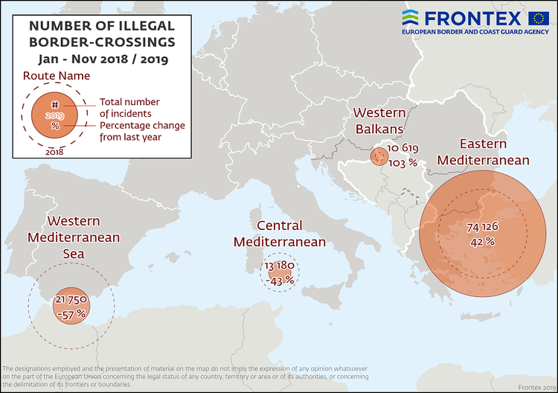

**Eastern Mediterranean**

Even though the number of irregular migrants taking the Eastern Mediterranean route in November fell 20% from October to around 9 700**, it still accounted for two-thirds of all the detections of illegal border crossings into the European Union.

Despite the slowdown last month in large part due to poor weather conditions, the total number of detections in this region in the first 11 months of this year was 42% higher than a year ago at more than 74 100.

In 2019 on the Eastern Mediterranean route, Afghans accounted for nearly one of every three migrants detected, while Syrians accounted for another quarter of the irregular migrants.  
  
**Western Mediterranean**

The number of irregular migrants crossing the Western Mediterranean in November fell 80% from the previous month to 950.

The total for the January-November period stood at close to 22 200, less than half the figure from the same period of last year.

Moroccans accounted for 28% of the migrants on this route in the first 11 months of 2019, while Algerians made up another 17%.    
  
**Central Mediterranean**

The number of migrants passing through the Central Mediterranean in November stood at close 1 200 or 46% less than in the previous month.

The total for the first 11 months of the year reached nearly 13 200, down 43% from the same period of last year.

Nationals of Tunisia, Sudan, Côte d'Ivoire and Pakistan were the most represented nationalities on this route in the first 11 months of 2019.  
  
**Western Balkans**

There were more than 1900 detections of illegal border crossings recorded on this route in November. The total for the first 11 months reached more than 10 600, twice the figure from a year ago.

Nationals of Afghanistan accounted for nearly half of the migrants detected on this route.  
  
*The 11-month figure includes other less active migratory routes not mentioned in this press release.

**November 2019 data does not include the number of detections in Cyprus.  
  
Note: The preliminary data presented in this statement refer to the number of detections of irregular border-crossing at the external borders of the European Union. The same person may attempt to cross the border several times in different locations at the external border.